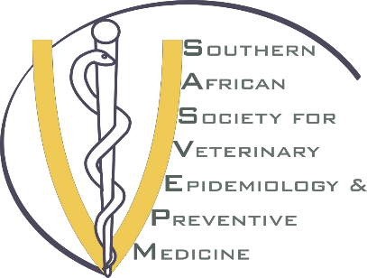

# SASVEPM Secretariat’s Report

# 2023 Annual General Meeting

**Compiled by Dr. Oonagh Pretorius**

**22 August 2024**

***SASVEPM Secretariat 2023-2025***

# ADMINISTRATION

## Executive Committee

As per SASVEPM’s AGM held on 24 August 2023 and the subsequent Executive Committee (ExCo) meeting, the new SASVEPM Executive was formed as follows:

The term of service for Executive Committee (ExCo) members is 2 years and there were no resignations during this year. Thus, the same ExCo members served until the end of the first year.

* Dr Mohamed Sirdar – President
* Prof. Chris Marufu – Vice President
* Dr Oonagh Pretorius – Secretary
* Dr Itumeleng Matle – Treasurer
* Dr Tandile Ndobeni – Executive Member (Communication)
* Dr Wonderful Shumba – Executive Member (Training)

This past year, the ExCo members met regularly via an online meetings platform. In total 12 meetings were recorded. They also communicated at least weekly via a private WhatsApp messaging group.

According to the Society’s constitution, the term of service for executive members is two years. Therefore, there will be no elections during this 2024 AGM.

## SASVEPM Membership

Our membership engagement remains robust, marked by sustained enthusiasm and active participation from our community. Building on the momentum gained from last year’s congress in Gaborone, we have observed a continued and growing interest in our society.

The members agreed in the 2019 AGM that the Society would grant membership to any person who has attended at least one SASVEPM Congress within 5 years. This year, the SASVEPM membership has grown to **1953 members,** from 1120 members last year.

## Secretary Equipment

The Secretary continues to us the official SASVEPM laptop according to the SASVEPM equipment policy. It was necessary to transition to a Microsoft Office Business account which now houses the SASVEPM document repository and will be used by the SASVEPM Secretariat going forward.

# COMMUNICATION & MEDIA

The ExCo Communications portfolio aims to ensure that the events of SASVEPM are well marketed on social media and to give constant feedback to the members about the developments and success of those events.

At the 2023 AGM, the SASVEPM members voted to have this year’s 21st SASVEPM annual congress in Cape Town, Western Cape, South Africa.

Over the past year, we have significantly **enhanced digital presence** through our online visibility with a revamped website modification and active social media engagement monthly.

## Social Media

The SASVEPM facebook and LinkedIn pages **are the social media platforms used to post u**pcoming activities and reports. The communication officer has posted regular updates about the society’s activities and reports throughout the year, which has led to expansion of our social media following.

## Website

Sourcebranding was contracted on the 23rd of September 2022 to enhance the SASVEPM website based on the agreed assessment criteria which included among other experience in open source and website development, responsiveness, tax registration with the receiver of revenue, letter of recommendation from the past work, BEE certificate, registered company, and the quotation of the work. The ExCo had several meetings with the contracted service provider to work on action steps and milestones of the project. We are pleased with the completed website enhancement work. Currently, Sourcebranding offers maintenance and hosting services for the organization.

We are pleased to report that since the renovation of the website, our website traffic has grown.

## Communication

The Society’s mailing list has grown: active email addresses in the database have increased from 1780 to 2019 this past year. The ExCo use this database to contact members about issues related to training, congress, nominations, and other society affairs. Reports of all SASVEPM Annual Congresses and training activities are available on the society’s [website](https://sasvepm.org/) which has been renovated.

The Secretariat purchased a MailChimp licence which allows bulk email communication with up to 5000 contacts for **improved internal communication. This was done because of** SASVEPM’s growing membership throughout the southern African region and in anticipation of hosting ISVEE18 in 2027.

To ensure continuity between the changing ExCo members and portfolios, Sourcebranding was also requested to create official SASVEPM email addresses, including [secretary@sasvepm.org](mailto:secretary@sasvepm.org) to facilitate administration.

This year, we also published our first newsletter, following the Avian Influenza webinar in March 2024.

# PARTNERSHIPS & SPONSORSHIPS

# *Sponsorships*

The sponsorship landscape for the 2024 SASVEPM Congress has experienced noteworthy developments:

Regrettably, we have lost sponsorship from DTRA, which has previously been a valuable contributor to our congress. However, we are pleased to report that our partnership with OBP (Gold Sponsor) remains intact, ensuring their continued support for this year's event.

We have successfully secured sponsorships from HWSETA (Platinum Sponsor), Inqaba Biotech (Silver Sponsor), ARC OVR (Bronze Sponsor), and Deltamune (Exhibitor Sponsor). These new partners bring renewed vigor and resources, significantly enhancing our financial and logistical foundation for the 2024 congress.

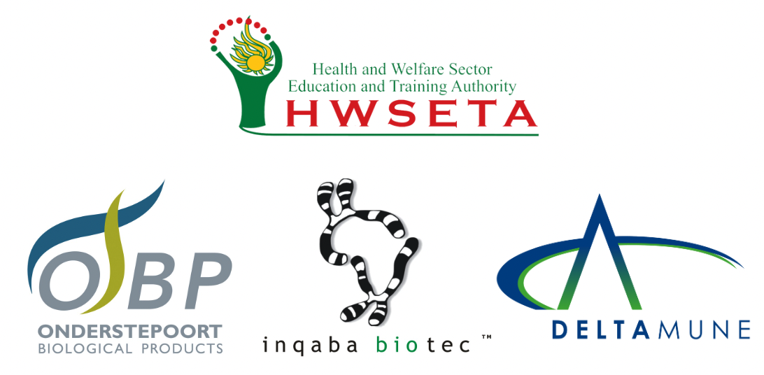



# *Liaison with Sponsors*

We have diligently maintained close collaboration with our sponsors, prioritizing clear communication and ensuring alignment with their expectations.

Our new sponsors have shown exceptional enthusiasm and commitment, actively contributing to the planning and success of the congress.

Regular updates and strategic discussions have been held with all sponsors, integrating their valuable input into our agenda and logistical arrangements.

# *Liaisons with Other Societies*

We successfully connected with the Society for Veterinary Epidemiology and Preventive Medicine (SVEPM) in the European Union, and we are honoured that Dr. Locksley Messam, a member of their executive committee, has agreed to serve as a keynote speaker at the 2024 congress.

Continued engagement with the ISVEE17 organizing committee has been fruitful, allowing our members to take advantage of early bird registration opportunities while awaiting confirmation from our funders.

The congress announcement was actively circulated at the 39th Annual World Veterinary Association (WVA) Congress 2024, with a particular emphasis on encouraging participation from Southern African countries through abstract submissions and active engagement in our congress.

# TRAINING & CAPACITY BUILDING

The ExCo Capacity Building and Training portfolio proposed and implemented several professional development initiatives for its members this financial year. The implementation was limited to a webinar and pre-congress workshop. One further training could be included before the end of the year, funds permitting.

An online webinar on Avian Influenza was conducted by SASVEPM on 14 March 2024, attended by 604 members representing 28 countries from 5 continents. This initiative was in response to the devastating H5N7 outbreak that severely impacted the sub-region, particularly South Africa's egg industry due to export bans. Avian influenza expert speakers included Dr. Grietjie de Klerk (DALLRD), Prof. Celia Abolnik (University of Pretoria), and Dr. Moetapele Letshwenyo (WOAH).

A two-day pre-congress workshop on Veterinary Biosafety and Method Validation fundamentals took place at Lagoon Beach Hotel from 19-20 August 2024. The workshop targeted South African provincial and state-owned enterprise laboratory officials. The workshop aimed to strengthen their understanding of these critical areas in veterinary diagnostics. This training was made possible through the generous support of HWSETA and SASVEPM.

# 21st ANNUAL CONGRESS OF 2024 IN CAPE TOWN, SOUTH AFRICA

We are delighted to report that there was a total of 255 **registrations** for the 2023 Congress, with 93 participating online and 162 delegates attending in person at the Lagoon Beach Hotel in Cape Town, South Africa. Participants came from 14 **different countries**, including: Australia, Belgium, Botswana, eSwatini, Kenya, Lesotho, Namibia, Nigeria, South Africa, Sudan, Sweden, USA, Zambia and Zimbabwe.

A very satisfactory number of abstracts were submitted for the congress this year, **83 abstracts** (four fewer than last year). It is encouraging to note this high level of interest from post-graduate students and para-veterinary staff. This translated into 39 oral presentations and 39 poster presentations in the congress program.

SASVEPM has specially invited three distinguished speakers to present keynote addresses at the congress. We warmly welcome Prof. Locksley Messam (University College Dublin, Ireland), Dr. Anne Conan (CIRAD, Zimbabwe), and Prof. Nenene Qekwana (University of Pretoria, South Africa). Together, we believe that these speakers will combine to focus and inspire our discussions within the congress theme of **Epi for Africa: Global Problems | Local Solutions.** We also celebrate our 21st annual congress since the beginning of this society; a very proud moment for us all. Therefore, the congress proceedings book will share the history and some special memories in a dedicated section to celebrate this moment.

## Recognition and Prizes

Two awards will be presented during the Gala dinner. The **SASVEPM Lifetime Achievement Award**, which was introduced in 2021, goes to Dr. Sewellyn Davey for her dedication to the South African Veterinary Services and the invaluable contribution she made to veterinary disease control and public health throughout her career. The **Willie Ungerer Award** for epidemiological excellence this year goes to Dr Moetapele Letshwenyo for his dedication to epidemiology and prevention and control of animal diseases in southern Africa.

The four prizes for presentations will be awarded on Friday during the congress closing ceremony:

* Best overall oral presentation (Prof. Gavin Thomson prize)
* Animal health technician prize
* Best post-graduate oral presentation
* Best poster presentation

# CONCLUSION

This 2023/2024 year has been busy for the SASVEPM ExCo. Many Society goals were achieved including updating the website; establishing official permanent SASVEPM email addresses; conducting training & capacity building activities; provincial rotation of the congress; and increasing the membership within the region.

While the loss of DTRA funding presents a challenge, the continued support from OBP and the addition of new sponsors—HWSETA, Inqaba Biotech, Deltamune, and ARC OVR—position us favourably for a successful 2024 SASVEPM Congress and beyond.

Finally, I would like to thank:

* The Lagoon Beach Hotel for hosting this meeting.
* All attendees either in-person or online for your participation.
* The ExCo for their tireless efforts to ensure smooth management of the society’s affairs.
* I must give a great appreciation to our partners and sponsors for their generous support.
* I wish to give huge thanks to VetLink for professionally managing their first SASVEPM congress and for their supports over the past year.

All reports and congress proceedings are available on the SASVEPM website.